Flight controls

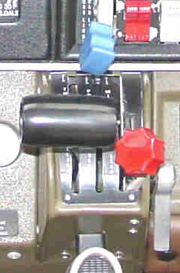Throttle. Black, smooth handle. Controls engine power. Push forward for more power, back for less. In the Archers, engine power controls RPM, shown on the tach. In the Dakota, engine power controls Manifold Pressure, which is shown on the Manifold Pressure gauge

Prop pitch control. Blue handle, ridges on one side. Controls the propeller pitch (angle) to ensure that the engine speed remains the same as power is altered. It's sort of like a gearshift for the propeller. The Archers do not have this control; propeller pitch is constant.

Mixture control. Red, bumpy handle. Controls fuel to air mixture (which should change with altitude). Push forward to richen mixture, back to lean the mixture. Pinch hitters should generally not lean the mixture until safely on the ground (pull back all the way to stop the engine). Lower altitudes want a richer mixture than higher altitudes to keep the engine happy.

Friction lever. Adjusts the friction on the engine controls (above)

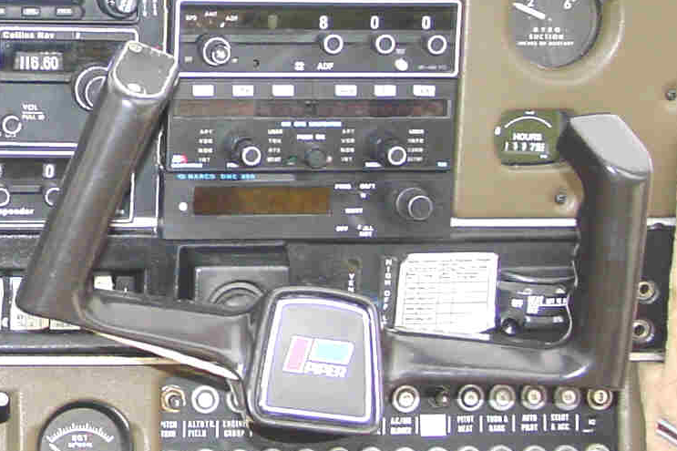
Control yoke. Controls pitch (nose-up, nose-down) and bank (tilting left, tilting right). Be aware of the pressure (resistance) as you move the controls in flight because this is far more important than the actual control position. You'll get a feel for it when you actually fly. Pushing forward pushes the nose down and the airplane goes faster. Pulling back pulls the nose up and the airplane goes slower. If the airplane goes too slow, the wing stalls. That's bad, so be careful. Note that pointing the nose up doesn't necessarily make the airplane climb - it also needs enough power and airspeed. ("Push forward the houses get bigger. Pull back, the houses get smaller. Keep pulling back, the houses get bigger again!") Turn the yoke to the left or right to begin to make the airplane bank. Once the airplane is banked at the angle you want (to start turning, for example), bring the yoke back near neutral and the airplane will stay banked. For shallow turns (the only kind a pinch hitter should make) you will need to keep a little bit of pressure to remain banked, and only a little bit of nose-up pressure to maintain altitude. Reverse the process to level the wings.

Pitch trim wheel (elevator trim wheel). This sets the "neutral" position of the control yoke pertaining to pitch (nose up, nose down), so that the pilot doesn't have to hold pressure against the control yoke to fly in any given configuration. It has a primary effect on airspeed - the airplane will then climb or descend based on power. (Remember, just pointing the nose up doesn't necessarily make the airplane climb.)

Electric trim control. (on pilot side) Can be used in lieu of manually turning the pitch trim wheel, although manually adjusting the trim gives better feedback.
Electric trim control on/off switch. Disables (or enables) electric pitch trim control. Pinch hitters should turn this off to keep things simple and avoid surprises.

Rudder trim wheel. Sets the neutral position of the rudder pedals (nose left, nose right) for forward flight to counteract unbalanced aerodynamic forces. It's probably already set correctly, and a pinch hitter shouldn't need to worry about it.

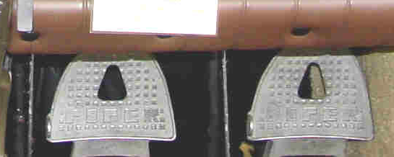
Rudder pedals. Pressing on a pedal pushes the nose in the direction of the foot you are using - to turn the nose right, press on the right pedal. This is the opposite of the way a sled works - at least the sleds I remember as a child. The top part of the same pedals control the brakes - one for each wheel. The effect on the nose of using one brake pedal is the same (on the ground) as the effect of using the rudder pedals in the air. If you need to go around, you'll probably need to press on the right rudder pedal to counteract propeller forces which would take you off course.

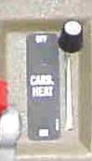
Carb heat control (Carburetor heat control). Used for a few moments to prevent ice from forming in the carburetor. Ice can form even at 70 degrees for technical reasons. If the engine is running roughly, this is one thing to try. Otherwise, safely ignored by pinch hitters.

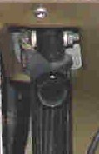
Parking brake.

Primary flight instruments.

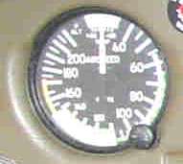
Airspeed indicator. Indicates speed through the air. This is different from ground speed because of winds. Generally safe speeds lie within the green arc. When landing, your speed will bleed down, perhaps below the green arc. This is ok once you're about to touch down.

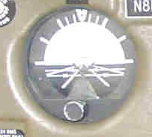
Attitude indicator, or Artificial Horizon. It mimics the view out the window - blue is sky, dark is ground, and the center "little airplane wings" shows how the airplane is pointed (up, down, banked, level...). The airplane might not be actually going in the direction it's pointed - for example pointing up does not mean climbing. If you are out of the clouds, you can safely ignore this instrument - it's better to look out the window.

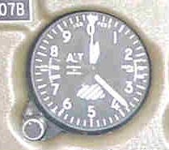
Altimeter. When properly set, it measures altitude (height) above sea level. This is not the same as height above the ground, but is a very useful reference, and is the primary reference for altitude. Read it like a clock - the short fat hand indicates thousands of feet, the long hand indicates hundreds of feet. (The little triangle at the tip of the really skinny hand indicates tens of thousands of feet). When you are on the ground, the altimeter should indicate the airport altitude.
Kollsman window, or just "window". This is where the altimeter is "set" so that it reads accurately. The altimeter setting corrects for variations in air pressure. Air traffic control will periodically give you the altimeter setting (it changes as you fly from one airmass to another). It is unlikely that a pinch hitter will need to worry about this.

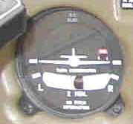
Turn Coordinator. The top part ("little airplane") indicates if the aircraft is turning or not, and the bottom part ("ball") indicates if the turn is coordinated or not (if you are banked properly for the amount of turning you are doing). If you are not in the clouds, you can safely ignore this instrument. (Some aircraft have a "Turn and bank indicator" instead - there are subtle differences between the two but they do essentially the same thing.)

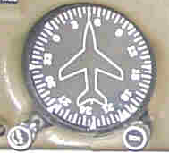
Directional Gyro (aka Gyrocompass or DG). Indicates heading (which direction the aircraft is pointing). It is more stable than a magnetic compass, but needs to be periodically checked against the magnetic compass. There are two knobs on the bottom, one is used to reset the compass as needed, the other is used to set the heading bug. Note that due to wind drift, the aircraft may not be travelling exactly in the direction it's pointing.

Heading bug. An indicator on the Directional Gyro which indicates to the autopilot which direction to fly, and reminds the pilot which direction he wants to fly. It is controlled by a knob usually marked HDG on directional gyro.

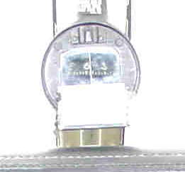
Magnetic compass. Jiggles a lot, does not read correctly except in straight and level flight. The Directional Gyro is periodically reset by referring to the magnetic compass, but only in straight and level flight.

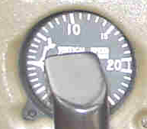
Vertical speed indicator (VSI). Indicates (after a short time lag) a climb or descent. If you are not in the clouds, you can safely ignore this instrument. You can see by the movement of the altimeter whether you are going up or down.

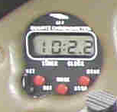
Clock. (Dakota's digital clock shown) Use it to keep track of how much fuel you have left. Or use your watch.

Radio stack (Avionics):

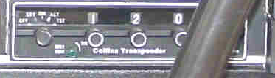
Transponder. This radio sends back a signal in response to radar, which contains the numbers in the windows ("squawk code" - 1200 shown) and (sometimes) altitude. For instrument flight (and some VFR flight) the codes are assigned by ATC (Air Traffic Control) and help the controllers see you on radar. There are two special codes of interest to the pinch-hitter: 1200 means "VFR flight - nothing special" and 7700 means "emergency".

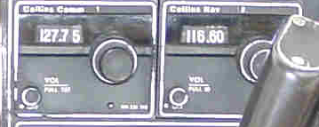
Nav-Comm radio (#2). This is a single box with two radios in it - a Nav (navigation radio) and a Comm (voice communication radio). Typically, the Nav is on the right and the Comm is on the left (maybe they should call it a Comm-Nav, but they don't). The navigation radio data is displayed on the OBS (the round dial usually to the left of it) and can usually be ignored by a pinch hitter, who will be navigating by other means. The Comm is typically on the left

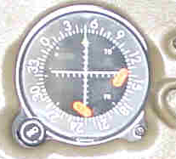
OBS (Omni-Bearing selector). This indicator, when properly set, uses a needle to give a fly-left or fly-right indication to the pilot to stay on the selected radial. (A radial is a course to or from a VOR radio station - a VOR is a special kind of navigation radio.) A pinch hitter will most likely be navigating by other means, so this is safely ignored.

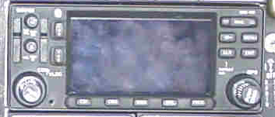
GPS (Global Positioning System) receiver. Useful navigation device - complex to set up, simple to follow. Don't let it distract you, but if you know how to use it, it will lighten your load. It often contains another Nav-Comm, usually #1.

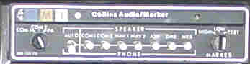
(Audio panel). Generally located at the top of the radio stack, it selects which radios you will hear (and whether you hear them through the speakers or through the headset), and which radio you will transmit on. It also contains a marker beacon receiver, which indicates when the aircraft is over certain radio beacons on instrument landings by lighting up and sounding tones. Safely ignored. Become familiar with the lights and tones so you know what to ignore. Learn how to switch between radios.

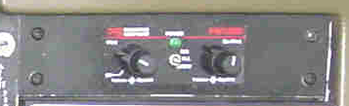
Intercom system. Allows pilot and passengers to converse through headsets. Sets volume and squelch. Squelch silences the intercom unless somebody is speaking (loudly enough).

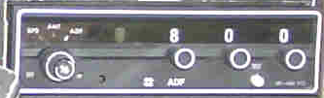
ADF (Automatic Direction Finder). Another kind of navigation radio - it is connected to an indicator with a needle that points directly to the selected radio station.

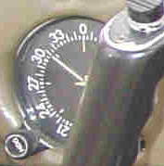
ADF indicator. Points to the station selected in the ADF radio. Safely ignored by the pinch hitter.

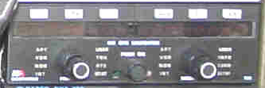
LORAN receiver. LORAN is yet another kind of navigation system. Safely ignored, though if you know how to use it, it can give you the course to any airport in the database, which you can then use to navigate with.

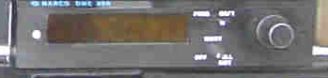
DME (Distance Measuring Equipment). Reads out (among a few other things) the distance to the selected navigation radio station. It can be coupled to a Nav-Comm radio (to select the same station), or it can be set to operate independently.

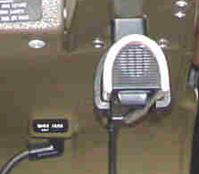
Microphone. If you aren't using a headset, use this to talk on the radio. Push the push-to-talk switch to talk - release when done.

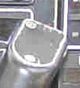
Yoke mounted transmit switch. If using a headset, push to transmit, release to listen. There are other buttons on the yoke of some aircraft; they switch radios (be careful - if you can't communicate any more, you might have hit one by accident) and control the electric trim.

Engine instruments
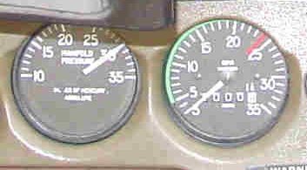
Manifold Pressure gauge (not present on some aircraft). Indicates manifold pressure (how hard the engine is working to spin the propeller)

Tach (Tachometer). Indicates engine and propeller speed. Keep propeller speed in the green arc.

On simple aircraft (Archers), the (black) throttle directly controls engine and propeller speed. Stay in the green arc (on the Tach) except when max power is needed to go around for another landing attempt.

On more complex aircraft (Dakota), the (max) propeller speed is set by the (blue) prop control, and the manifold pressure is controlled by the (black) throttle. Propeller speed will remain constant throughout a wide range of throttle settings, but the manifold pressure will change as the engine puts out more power.

Oil temperature gauge.

Oil pressure gauge.

Fuel gauges. - one for each tank.

Alternator gauge - measures electrical load, the exact details of which differ from aircraft to aircraft.

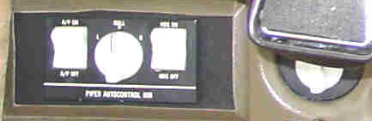
Autopilot. These can be quite sophisticated, or quite simple. Flying 20s planes have a simple wing leveler which can also be coupled to the Directional Gyro (DG). Before engaging heading mode, be sure the heading bug in the directional gyro is set to where you want to go!

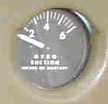
Suction gauge. Indicates the amount of air pressure running the flight instruments. (yes, some flight instruments are powered by airflow from an engine driven vacuum pump)

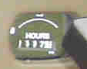
Hobbs meter. Indicates how much total time the engine has been running since the beginning of meaningful time (usually since the plane was new). You can ignore it.

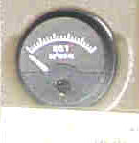
EGT (exhaust gas temperature). Used for leaning the engine (adjusting the fuel-air mixture). Safely ignored by pinch hitters.

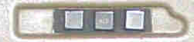
Warning lights for low vacuum, low electrical power, and low oil pressure. You may get a low vacuum warning indication if you pull the power back. This is normal, since the vacuum pump is driven by the engine.

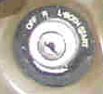
Starter and magneto switch (key switch). If turned to off, the engine will probably stop pretty soon (although the proper way to turn the engine off is to pull the (red) mixture control all the way back). Magnetos are like spark plugs that don't need electricity. Turn it off after a crash landing.

Electrical switches and circuit breakers

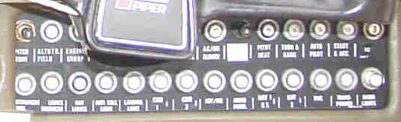
Circuit breakers. In general they should all be in - though there are a few that stick out a bit (so they can be pulled out by hand) Safely ignored by pinch hitters.

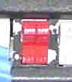
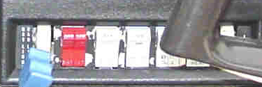
Master switch. (red) Controls electricity to all electrical items in the airplane. Does not affect the engine, which can run without electricity. The switch is in two halves - one half controls the battery, the other half controls the alternator (which is recharging the battery). Turn it off after a crash landing.

The grey rocker switches, in order, are:
Fuel pump switch (electric fuel pump). The engine driven fuel pump is usually sufficient. If it fails, this is a backup. It's also used when starting the engine.

Landing light switch. Like a car headlight - use when landing at night to help you see the runway. Also handy in busy traffic areas, especially at night, to make the airplane more visible.

Anticollision (Strobe) light switch. Use in flight to make the aircraft more visible, especially at night. Turn off on the ground or in clouds to avoid vertigo.

Pitot heat switch. The pitot tube is under the wing and measures ram air pressure, from which airspeed is computed and displayed. The pitot heat switch heats the pitot tube so ice doesn't form, if you are in the clouds or rain and it's a bit cold.

Left to right, the names spell FLAP.

On either side of the rocker switches are "roller" switches:

Nav lights / radio lights switch. Nav lights are the red and blue lights on the wingtips. The first click turns the nav lights on, then the knob turns more to raise the level of the panel and radio lights.

Beacon switch. Controls the rotating or flashing light on the tail. Use at night to make the airplane more visible.


Radio master switch. (Avionics master switch) Controls power to the radios. When off, prevents electrical surges (from starting or stopping the engine) from damaging radios.

Other

Fuel selector. Selects tank from which fuel is supplied to the engine. Be sure you are always drawing fuel from a tank that actually has fuel. Switch off after a crash landing.

